Unit 8 Don't push, please 同步练习
- 单项选择。
1. He is not honest. ______ believe him.
A. Not B. Don’t C. To not D. Not to
2. _____ in the street. It’s dangerous.
A. Not play B. Not to play C. Don’t play D. Don’t to play
3. Her doctor said: “________ work so hard”
A. Stop B. Don’t C. Can’t D. No
4. ________him the secret, will you?
A . Don’t tell B. Not to tell C. Not telling D. No telling
5. Please ________ look outside. Look at the blackboard.
A. not B. don’t C. aren’t D. can’t
6. sleep in class.
A. Can’t B. Don’t C. No D. Not
7. Please play volleyball here.
A. please B. do C. don’t D. not
二、根据图片写句子。
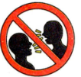

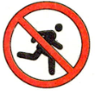

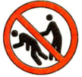

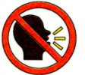

三、汉译英
推
说话
吵闹
排队
清洗

答案：
一、B C B A B B C
二、don’t talk; don’t run; don’t oush; don’t shout
三、push; talk; shout; queue up; clean up

